Neil Joseph Fischer, Sr.  Neil Joseph Fischer, son of John George Fischer and Catherine Margaret Gildea, was born October 6, 1925 in Savannah, Georgia. The third of four children born to Johnny and Katie Fischer, Neil was baptized at St. Patrick’s Catholic Church, was an altar boy at Blessed Sacrament Catholic Church, and attended Marist School for Boys.  Neil’s roots run deep in Georgia soil, his ancestors having secured land grants in the Colony of Georgia in 1763. As a young man, Neil showed Tennessee Walking horses with Bob and Edith Jenkins competing in events throughout the South. It was the Jenkins who introduced him to his future bride, Mary Ann Saraf whom he married at Sacred Heart Catholic Church in 1951.  Neil was a member of the "Greatest Generation," proudly serving his country in World War II as a Gunners Mate 2nd Class, U.S. Navy aboard the Destroyer Escort Richard S. Bull in the Pacific Theater.  Until his marriage in 1951, Neil worked at Gildea’s Bar on Victory Drive with his Uncle Joe Gildea and other family members, but he made the automobile business his career. In Savannah, Neil worked at Ray Clanton Motors, Dixie Chrysler Plymouth, and DeRenne Chrysler Plymouth, and was the proprietor of Fischer Auto Parts on Waters Avenue and DeRenne Avenue. In 1970, Neil acquired Leesburg Chrysler Plymouth in Lake County, Florida, where he was known as "The round man with the square deal."  Neil enjoyed fishing, bowling, golf, and flying. His love for flying led him to get his pilot's license in 1961. Neil was an avid fan of the Georgia Bulldogs, and some of his happiest times were at the Georgia games. Through the years, Neil developed and maintained strong relationships with the coaches and many of the players.  Neil had a big heart and was always helping others. While in Leesburg, he helped sponsor a large Vietnamese family rescued during the fall of Saigon in 1973. Today, all are faith-filled, proud, hard working Americans.  Neil is preceded in death by his brother John (Buddy) Fischer, his sister Henrietta (Retta) Russell, and two grandsons. Neil is survived by his wife of 58 years, Mary Ann Saraf Fischer; his children: Kim Peters (Oliver), Neil J. Fischer, Jr. (Judy), Robert Fischer (Jayne), Steven Fischer (Gabriella); grandchildren: Christopher and Ashley Peters, Catherine, Patrice, Robert, Geoffrey, Patrick, Alexis and Mary Sophia Fischer; brothers, Francis (Bootsie) and Charles (Chuck) Fischer, and many nephews and nieces. | Celebration of the Funeral Mass for  Neil Joseph Fischer, Sr.  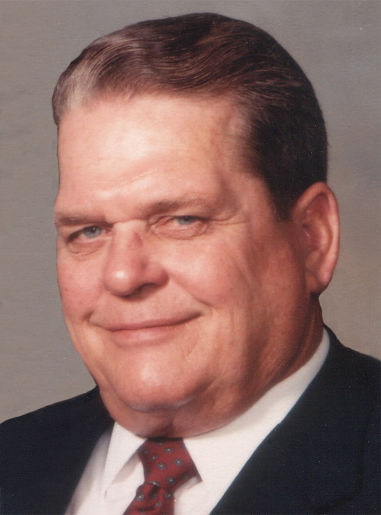  October 5, 1925 - April 15, 2010  Eternal rest grant unto him, O Lord,  and let perpetual light shine upon him.  May his soul and the souls of all the  faithful departed, rest in peace.  St. James Catholic Church  8412 Whitfield Avenue  Savannah, GA 31406  April 19, 2010  10:00 a.m.
Introductory Rites  Greeting  Sprinkling with Holy Water  Placing of the Pall  Entrance Procession  Hymn: On Eagles Wings sung by Ashley Peters  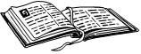Liturgy of the Word  First Reading: 2 Timothy 4:5-8  Responsorial Psalm: Psalm 23  Second Reading: Wisdom 3:1-6, 9  Gospel Acclamation (Stand)  Gospel: John 14:1-6  Homily  General Intercessions  Liturgy of the Eucharist  Preparation of the Altar and Gifts  Hymn: How Great Thou Art Word & Song #730  Eucharistic Prayer and Acclamations | Communion Rite  Our Father  Sign of Peace  Lamb of God: Mass of Creation  Communion Hymn: I Am The Bread of Life Word & Song #505  Prayer After Communion  Final Commendation  Hymn: May The Angels Gather You Word & Song #554  Final Prayer  Closing Hymn: Be Not Afraid Word & Song #676  Celebrant: Father Mark R. Ross  Music: Helen Beddow  Pallbearers: Neil, Robert and Steven Fischer; Oliver and Christopher  Peters, Robert, Geoffrey, and Patrick Fischer  Lectors: Patrice and Catherine Fischer  Presenting the Gifts: Ashley Peters, Alexis and Mary Sophia Fischer  Altar Server: Madison Phillips

