Neil Fischer’s grandfather came to America at the age of 19. His name in America was John Frederick Fischer. It appears his name was Johann Frederich Fischer. Here is the passenger list with his name on it and it appears he traveled with Hinr. Kohnemann on the Weser from Bremen, Germany on 14 September 1880, arriving in New York at Castle Garden on 28 September 1880. They state on their Naturalization papers that they arrived in Savannah on 3 October 1880, so they must have known people in Savannah and came via ship or train as soon as they arrived. Johann is the last name on the second page below. There were 19 pages of people, I have just pulled the first with the ship info and the one with Johann and Hinr. Kohnemann.
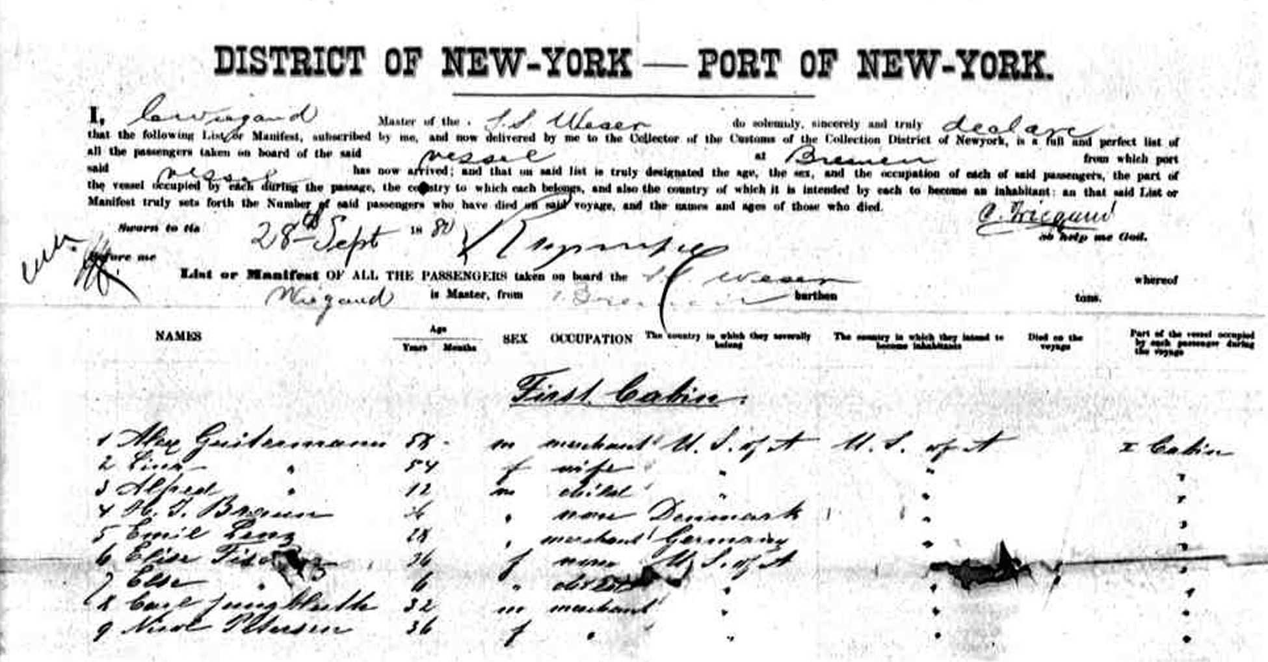

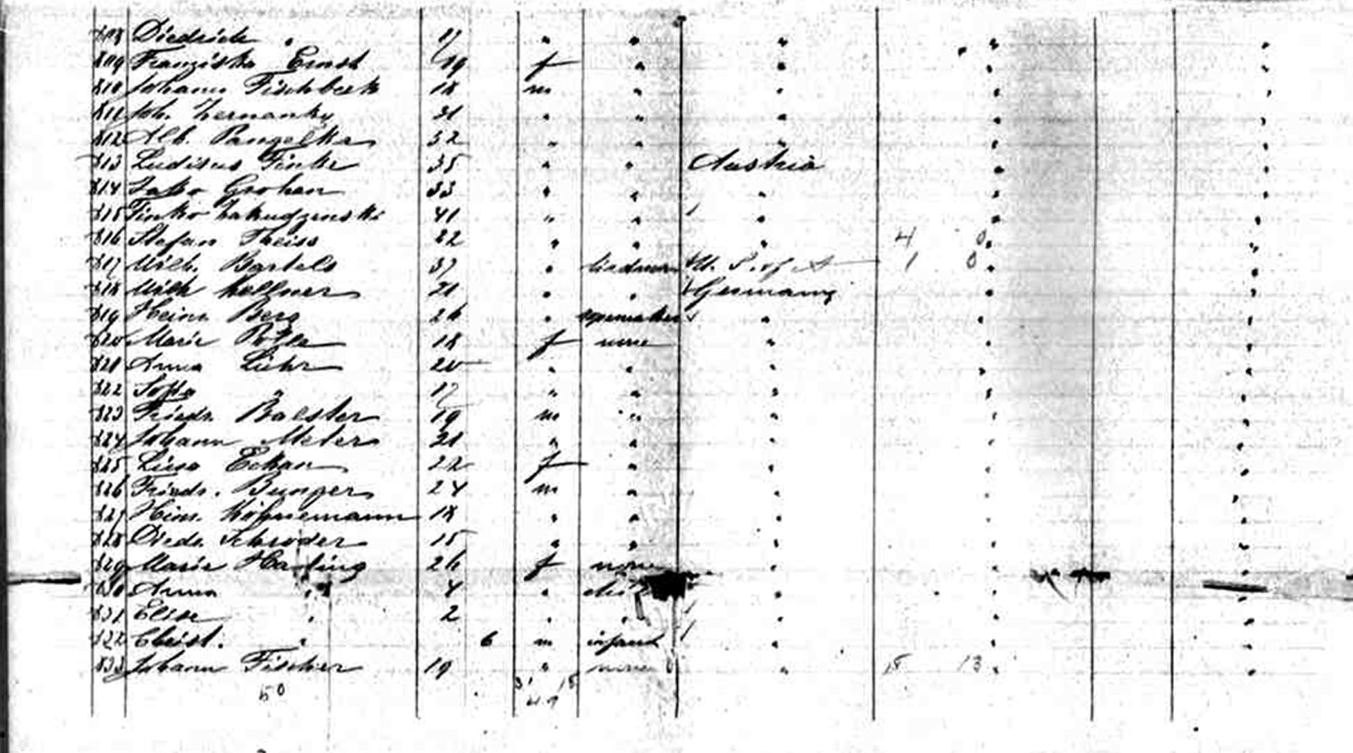

Ship Information
Ship Name: Weser
Years in service: 1867-1896
Funnels: 1
Masts: 2
Shipping Line: North German Lloyd
Ship Description: Built by Caird & Co., Greenock, Scotland. Tonnage: 2,871. Dimensions: 351' x 40'. Single-screw, 11 1/2 knots. Inverted engines. Two masts and one funnel. Iron hull.
History: Launched, March 19, 1867. Maiden voyage: Bremen-Southampton-New York, June 1, 1867. Re-engined with compounds in 1881. Speed increased to 13 1/2 knots. Scrapped in 1896. Running mates: America, Deutschland, Hansa, Hermann and Union.

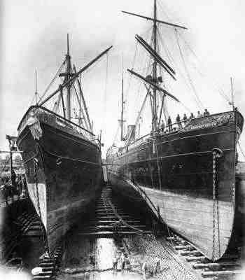

The next page is Grandpa’s Declaration of Intention to become a citizen of the United States and forever reject his country of birth. That is his actual signature on the bottom of the document signed 5 June 1886.
